**Word Processing**

**Class Five**

**Lab 14**

|  |
| --- |
| Lab Objectives:  * Ribbon * Backstage view * Ruler |

# Getting to know Word 2010

## Word 2010 is a bit different from earlier versions, so even if you've used Word before you should take some time to familiarize yourself with the interface.

# The Ribbon

## The new tabbed Ribbon system was introduced in Word 2007 to replace traditional menus. The Ribbon contains all of the commands you'll need in order to perform common tasks.

## It contains multiple tabs, each with several groups of commands, and you can add your own tabs that contain your favorite commands. Some groups have an arrow in the bottom-right corner that you can click to see even more commands.

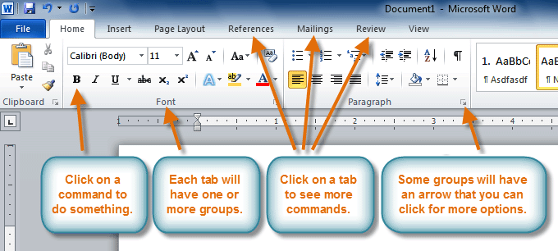

## Certain programs, such as Adobe Acrobat Reader, may install additional tabs to the Ribbon. These tabs are called add-ins.

# To minimize and maximize the Ribbon:

## The Ribbon is designed to be easy to use and responsive to your current task; however, you can choose to minimize it if it's taking up too much screen space.

## Click the arrow in the upper-right corner of the Ribbon to minimize it.

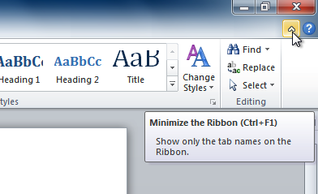

## To maximize the Ribbon, click the arrow again.

## When the Ribbon is minimized, you can make it reappear by clicking on a tab. However, the Ribbon will disappear again when you're not using it.

# To customize the Ribbon:

## You can customize the Ribbon by creating your own tabs with the commands you want. Commands are always housed within a group, and you can create as many groups as you want in order to keep your tab organized. If you want, you can even add commands to any of the default tabs, as long as you create a custom group in the tab.

## Right-click the Ribbon and select Customize the Ribbon. A dialog box will appear.

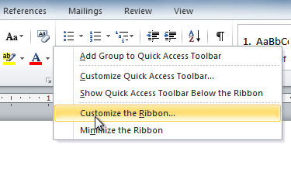

## Click New Tab. A new tab will be created with a new group inside it.

## Make sure the new group is selected.

## Select a command from the list on the left, then click Add. You can also drag commands directly into a group.

## When you are done adding commands, click OK.

## IMG_257

## If you don't see the command you want, click the Choose commands from: drop-down box, then select All Commands.

## IMG_258

# Backstage view

## Backstage view gives you various options for saving, opening, printing, and sharing your files. It's similar to the Microsoft Office button menu from Word 2007 and the File menu from earlier versions of Word. However, instead of just a menu it's a full-page view, which makes it easier to work with.

### To get to Backstage view:

## Click the File tab.

## IMG_256

## You can choose an option on the left side of the page.

## To get back to your document, click any tab on the Ribbon.

## Click the buttons in the interactive below to learn about the different things you can do in Backstage view.

## IMG_257

# The Quick Access toolbar

## The Quick Access toolbar, located above the Ribbon, lets you access common commands no matter which tab you're on. By default, it shows the Save, Undo, and Repeat commands. You can add other commands to make it more convenient for you.

### To add commands to the Quick Access toolbar:

## Click the drop-down arrow to the right of the Quick Access toolbar.

## Select the command you want to add from the drop-down menu. It will appear in the Quick Access toolbar.

## IMG_258

# The Ruler

## The Ruler is located at the top and to the left of your document. It makes it easier to adjust your document with precision. If you want, you can hide the Ruler to free up more screen space.

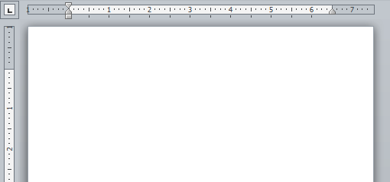

### To hide or view the Ruler:

## Click the View Ruler icon over the scroll bar to hide the ruler.

## To show the ruler, click the View Ruler icon again.

## IMG_260